THE NEXT EVOLUTION OF AI
Welcome to this overview of the Professional Certificate in RAG and Agentic AI

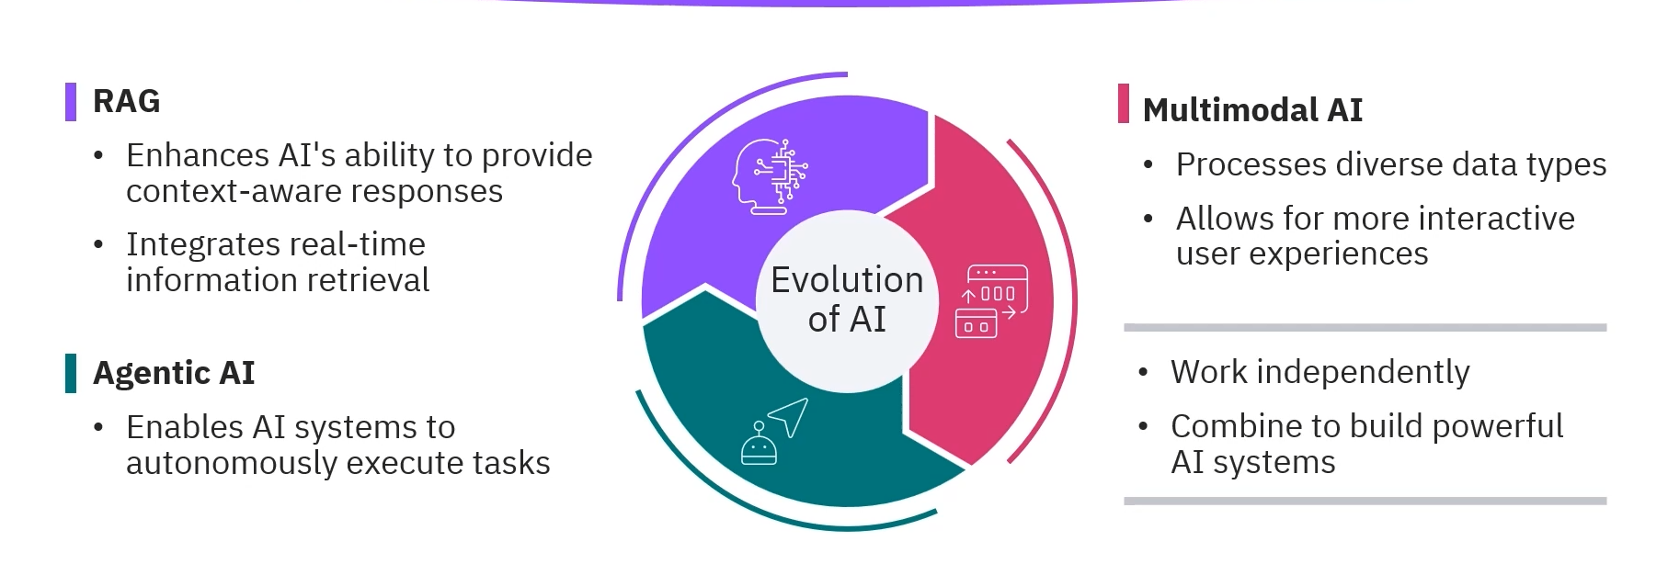
- Through this program, you'll gain the expertise to build and implement AI applications that combine these powerful techniques, preparing you for the next wave of AI-driven innovation.
- 
 